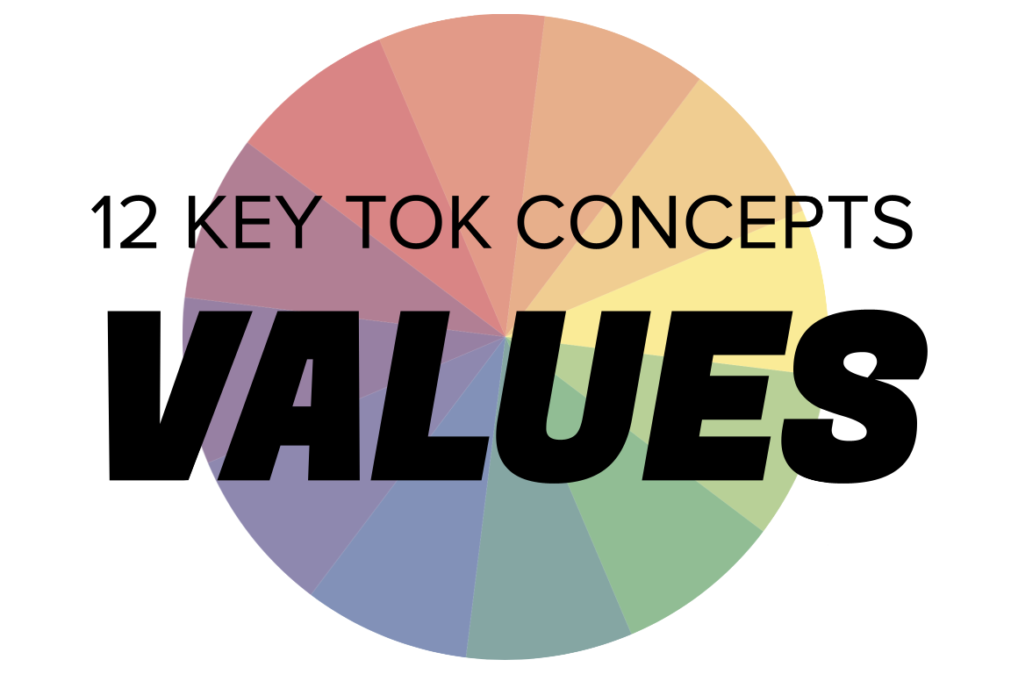 | VALUES

Understanding the 12 key concepts
- The 12 key concepts are ones that have been identified as having a particular significant relationship to knowledge.
- Understanding, exploring, and using these concepts will help you to understand the way knowledge is produced and used, within the core and optional themes, and the areas of knowledge.
- You should also try to use the key concepts as extensively as possible in the two TOK assessment tasks.
Starting points for values  - How many online definitions can you find for ‘values’?  - Which one do you think best sums up this concept, and why?  - Which of the quotes below do you think provides us with the best insight into values? Are there any you disagree with?  - What is the relationship between knowledge and values? | Quotes on values  - The aim of education is the knowledge, not of facts, but of values. William Inge  - Most sets of values would give rise to universes that, although they might be very beautiful, would contain no one able to wonder at that beauty. Stephen Hawking  - For me, the only sources of moral values are the pursuit of understanding and the pursuit of happiness. Matthew Stewart  - When history is erased, people's moral values are also erased. Ma Jian  - Intellectuals are people who believe that ideas are of more importance than values. That is to say, their own ideas and other people's values. Gerald Brenan  - When knowledge is cut off from traditional values, it becomes disastrous. Rajnath Singh
Interlinking the key concepts  - Can we ever be objective about our values?  - What role does culture play in generating values?  - Do our values require evidence?  - How much certainty do we require to construct our values?  - Which plays more of a role in the way we produce knowledge - our values, or power? | Relating values to the TOK course  - What is the relationship between the development of our values and the areas of knowledge?  - Which of the areas of knowledge deals most intimately with values?  - Does the way we use language have ethical implications?  - Should we draw on religious knowledge to construct our values?  - Does technology have a moral affiliation?
Relating values to the TOK exhibition  - IAP-11: Think about whether new knowledge can change established beliefs or values  - IAP-15: Think about how our values can act as a constraint on the production of knowledge  - IAP-16: Think about how our values guide us in judging whether seeking certain types of knowledge is ethically acceptable  - IAP-27: Think about how our values help us to ascertain whether knowledge carried with it ethical obligations  - IAP-34: Think about how our values affect how we acquire knowledge  - IAP-35: Think about how our values affect how we produce knowledge | Relating values to the Big Questions  - BQ1 - What are the sources of our moral knowledge?  - BQ2 - What is the relationship between knowledge and the construction of our values?  - BQ3 - How is/should knowledge be communicated in a ‘moral way’?  - BQ4 - Do different perspectives have different approaches to values?  - BQ5 - How does moral knowledge change over time?  - BQ6 - What makes an expert knower about ethics?

Real-world contexts for values

The media sources below explicitly mention certainty, and discuss this key concept in a real-world context. Use the find command (ie Command/Control+F) to locate the term in the article or transcript of the video, and you’ll see where it features. Check back regularly, as we update these media sources every month.
Big Question / knowledge framework | Description of media source and story and links to the course
BQ1 / Nature & scope | A History Today article, considering whether we can explain modern politics (eg Brexit) via historical analogies. History, Human sciences, Politics
BQ2 / Values | A Guardian article, looking at the work of environmental artist Agnes Denes, who planted a field of wheat in Battery Park, Manhattan. The arts, Natural sciences, Human sciences  A Big Think article, looking at the Inglehart-Welzel World Cultural map, which arranges nations according to their values and religious outlooks. Religion, Human sciences, Politics  A National Geographic article, looking at the way in which many people are drawing on art to make sense of, and communicate their response to, the Covid crisis. The arts, Natural sciences, Human sciences, Mathematics, Politics  The philosopher Daniel DeNicola argues in Aeon that we don’t have the freedom to believe in what we choose; our beliefs must be supported by valid evidence. Knowledge & the knower, Human sciences
BQ4 / Perspectives | A Conversation article, looking at how our judgement of when life begins is as much a matter of politics as it is about science. Politics, Natural sciences, Religion, Human sciences

